A Mini Project Report
On
ONLINE FUEL SERVICES
Submitted in partial fulfillment of the
Requirements for the award of degree of
Bachelor of Technology
In
Computer Science and Engineering

by
Gurappagari Tilak,
(14H61A0576)

N Vishal Yadav ,
(14H61A0596)

U S Anirudh,
(14H61A0561)

G Rohith
(12H61A05M0)

Under the Guidance of
Mr.Madar Bandu,
Asst. Professor,


ANURAG GROUP OF INSTITUTIONS
(Formerly CVSR College of Engineering)
(An Autonomous Institution, Approved by AICTE and NBA Accredited)
Venkatapur (V), Ghatkesar (M), RR Dist., T.S-500088
(2014-2018)
Department of Computer Science and Engineering



CERTIFICATE

This is to certify that the project entitled “Online Fuel Services” being submitted by Gurappagari Tilak bearing the Hall Ticket number 14H61A0576, N Vishal Yadav bearing the Hall Ticket number 14H61A0596 , U S Anirudh bearing the Hall Ticket number 14H61A0561, and G Rohith bearing the Hall Ticket number 12H61A05M0 in partial fulfillment of the requirements for the award of the degree of the Bachelor of Technology in Computer Science and Engineering to Anurag Group of Institutions (Formerly CVSR College of Engineering) is a record of bonafide work carried out by them under my guidance and supervision from July 2017 to October 2017.
The results presented in this project have been verified and found to be satisfactory. The results embodied in this project report have not been submitted to any other University for the award of any other degree or diploma.

Internal Guide External Examiner Mr.Madar Bandu
Asst.Professor
Dept. of CSE

Project Coordinator Dr.G.Vishnu Moorthy,
Pallam Ravi Professor and Head,
Asst.Professor Dept. of CSE

ACKNOWLEDGEMENT

It is our privilege and pleasure to express profound sense of respect, gratitude and indebtedness to our guide Mr.Madar Bandu, Asst. Professor, Dept. of Computer Science and Engineering, Anurag Group of Institutions (Formerly CVSR College of Engineering), for his indefatigable inspiration, guidance, cogent discussion, constructive criticisms and encouragement throughout this dissertation work.
We express our sincere gratitude to Dr. G.Vishnu Moorthy, Professor & Head, Department of Computer Science and Engineering, Anurag Group of Institutions (Formerly CVSR College of Engineering), for his suggestions, motivations and co-operation for the successful completion of the work.
We extend our sincere thanks to Dr.K.S.Rao, Director, Dr.V.Vijaya Kumar, Dean, Dept. of CSE & IT, Anurag Group of Institutions (Formerly CVSR College of Engineering), Venkatapur (V), Ghatkesar (M), Ranga Reddy (Dist), for their encouragement.

Gurappagari Tilak(14H61A0576),

N Vishal Yadav(14H61A0596),

U S Anirudh(14H61A0561),

G Rohith (12H61A05M0).

DECLARATION

We hereby declare that the project work entitled “Online Fuel Services” submitted to the Anurag Group of Institutions(Formerly CVSR College of Engineering) in partial fulfillment of the requirements for the award of the degree of Bachelor of Technology (B.Tech) in Computer Science and Engineering is a record of an original work done by us under the guidance of Mr.Madar Bandu, Asst. Professor and this project work have not been submitted to any other university for the award of any other degree or diploma.
Gurappagari Tilak(14H61A0576),

N Vishal Yadav(14H61A0596),

U S Anirudh(14H61A0561),

G Rohith (12H61A05M0).

Date: 26-october -2017

CONTENTS

- Abstract
- introduction (detailed),activity diagrams
- Software Requirement Specifications ( actors- example:client,admin, customer etc )
use case diagrams :
3.1) for each actor write usecase (detailed)
3.1.2) for each programming file explain about the parameters, functions, flow chart
4. data based design(with ER- diagram)(explain about each table with its schema)
5. Test cases
6. Deployment (deployment diagrams)
7. Conclusion and feature enhancement

1 ABSTRACT

An online fuel services that permits a customer to submit online orders for items from a store that serves both walk-in customers and online customers. The online shopping system presents an online display of an order cut off time and an associated delivery window for items selected by the customer. The system accepts the customer's submission of a purchase order for the item in response to a time of submission being before the order cut off time. The online fuel service does not settle with a credit supplier of the customer until the item selected by the customer is picked from inventory but before it is delivered. Therefore, the customer can go online and make changes to the order. In addition, available service windows are presented to the customer as a function of customer selected order and service types and further, the order pickings is assigned in accordance with a picker's preference. Successive items selected for purchase are placed into the virtual shopping cart until a customer completes their shopping trip. Once the customer decides to submit a purchase order, the customer may print the contents of the virtual shopping basket in order to obtain a hard copy record of the transaction

CHAPTER-2
INTRODUCTION
2.1 SCOPE
Primarily, the scope pertains to the E-Store product features for making Online Fuel services project live. It focuses on the company, the stakeholders and applications, which allow for online sales, distribution and marketing of electronics. This SRS is also aimed at specifying requirements of software to be developed but it can also be applied to assist in the selection of in-house and commercial software products. The standard can be used to create software requirements specifications directly or can be used as a model for defining a organization or project specific standard. It does not identify any specific method, nomenclature or tool for preparing an SRS.

2.2 EXISTING SYSTEM
In the existing system, a person has to travel to the fuel station to fill the fuel. If the fuel is exhausted on the road , the person has to push his vehicle to fuel station or take another vehicle to get the fuel. In some cases we travel in the opposite way of our destination to fill the fuel.

2.3 PROPOSED SYSTEM
The proposed project concentrates on delivering fuel to the customer instead he comes to the fuel station. As people are used with the internet we see the future in this project .

2.4 OBJECTIVE OF THE PROJECT
To deliver fuel at the doorstep of customer. Deliver fuel at the time of emergency to the customer

2.5 SOFTWARE REQUIREMENTS
1. Client-side Technologies : HTML,CSS,Javascript,Bootstrap
2. Server-side Technologies : PHP
3. Database : MySQL
4. Operating System : Windows 7
5. Softwares : WAMP Server

2.6 ACTIVITY FLOW OF THE SYSTEM
ACTIVITY DIAGRAM
Activity diagrams are graphical representations of workflows of stepwise activities and actions with support for choice, iteration and concurrency.
DESCRIPTION
The activity diagram shows the workflow of the activities involved in the system. The User must register and successful registration must be continued with Login procedure. After logging in,the user has two options to do with, namely, buying the product, searching the product. These are the user activities in the system. The user can logout of the website after performing any of these activities. The admin has to login and there is no register option for admin. The admin can update the details of the products. The admin can logout of the website after performing the activities.
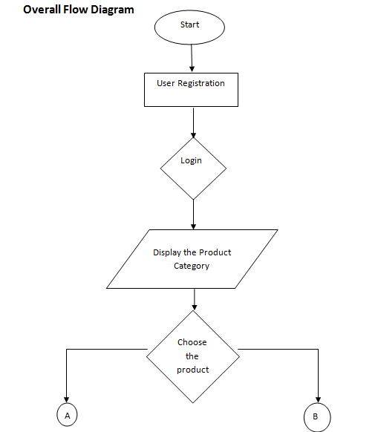
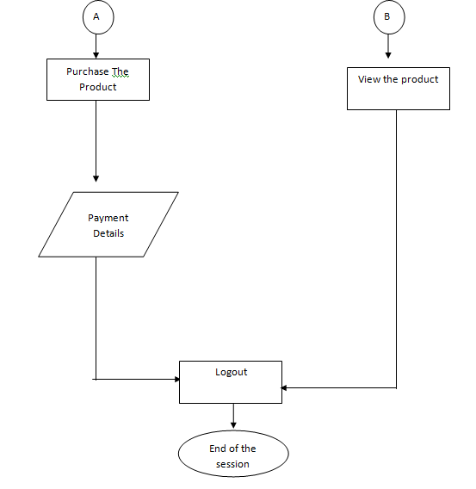

Fig.2.1.Activity Diagram

CHAPTER-3
SOFTWARE REQUIREMENTS SPECIFICATIONS
ACTORS
An actor is behaviour classifier which specifies a role played by an external entity that interacts with the subject (e.g., by exchanging signals and data), a human user of the designed system, some other system or hardware using services of the subject.
The term "role" is used informally as some type, group or particular facet of users that require specific services from the subject modeled with associated use cases. When an external entity interacts with the subject, it plays the role of a specific actor. That single physical entity may play several different roles, and a specific role may be played by single instances.

ACTORS IN THE PROJECT
- User
- Admin

S.No | Actor | Description
1. | User | - User can search the products.  - User can buy the products.  - User can cancel his order before placing.
2. | Admin | - Admin can update prices of every product.  - Admin can update the quantity of products available.

3.1 USECASE DIAGRAMS FOR EACH ACTOR
USECASE DIAGRAM
A use case diagram at its simplest is a representation of a user’s interaction with the system and depicting the specifications of a use case. A use case diagram can portray the different types of users of a system and the various ways that they interact with the system. This type of diagram is typically used in conjunction with the textual use case will often be accomplished by other types of diagrams as well.

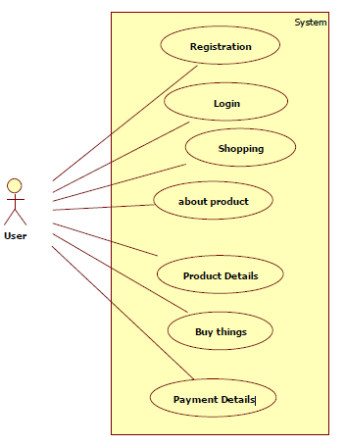
Fig.3.1.1.Usecase Diagram

USECASE DIAGRAM FOR USER
In the above use case diagram there is one actor and seven usecases.
Actor : User
This usecase diagram depicts the functions of the user like
1.Register
2.Login
3.view the products
4.Buy the products
5.cancel order before placed
6.Logout

USECASE DIAGRAM FOR ADMIN

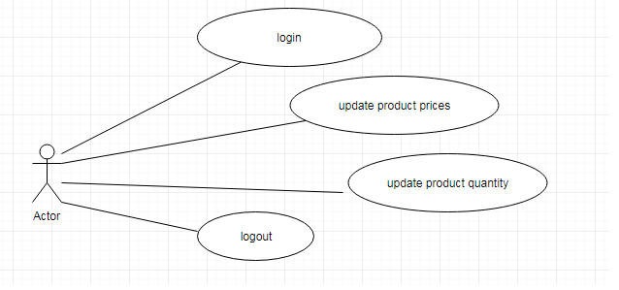

Fig.3.1.2.Usecase Diagram for Admin

In the above use case diagram there is one actor and four usecases.
Actor : Admin
This usecase diagram depicts the functions of the employee like
1.Login
2.Upadte product prices
3.Update product quantity
4.Logout

2.2 PROGRAM FILES
We have the following programming files in our project.
- index.html
- registration.php
- login.php
- petrol.php
- diesel.php
- lpg.php
- oils.php
- cart.php
- checkout.php
- contact.php
- aboutus.php
- admin.php
- userup.php
- db_connection.php
- getpass.php
- gotpass.php

3.3 PARAMETERS AND USER MANUAL
index.php
Parameters : none
It contains the code for starting page of the website consists of register, user login and admin login.
User Manual : User can select Register
User can select Login
Admin can select Login

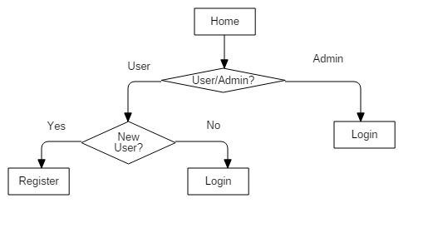
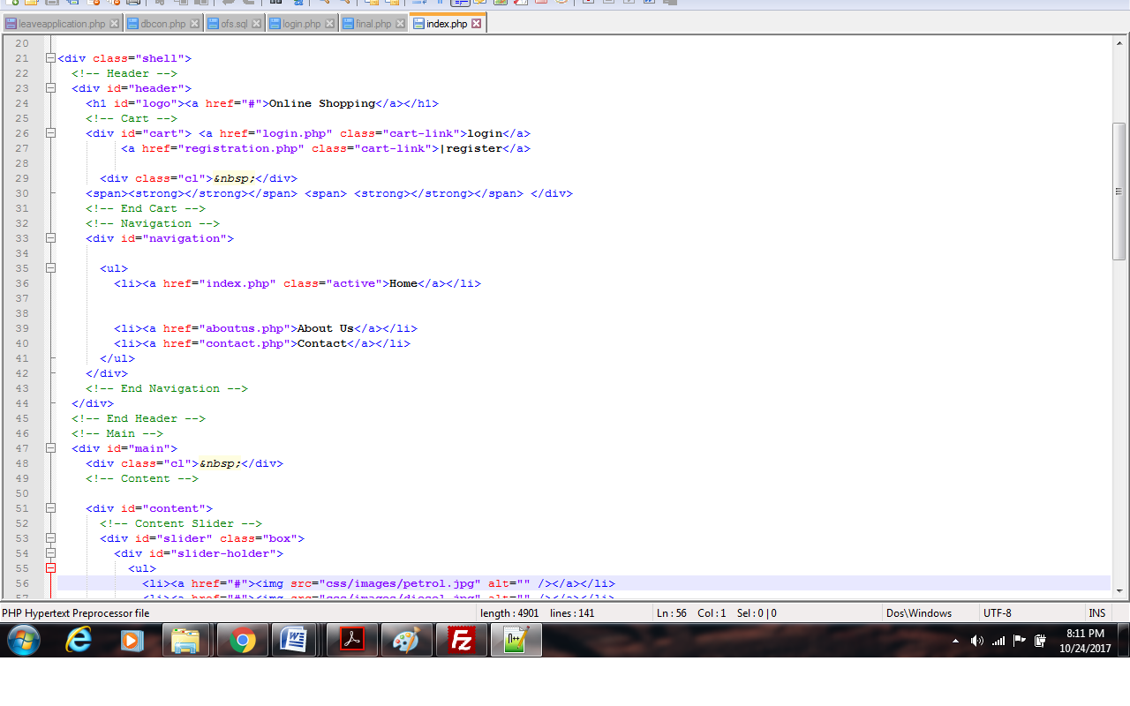fig 3.3.1.Index code

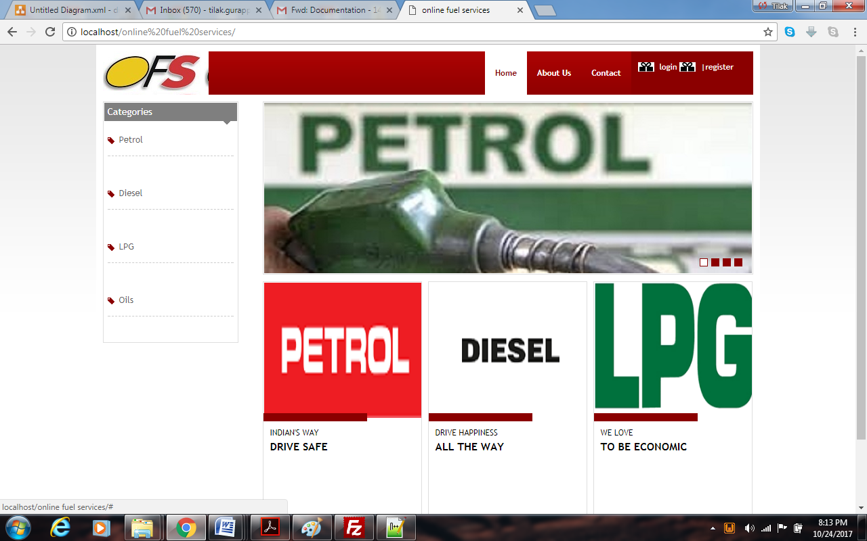
fig 3.3.2 Index webpage

registration.php
Parameters : Name, E-mail, Password,address,phone number.
This file makes the user to register with his/her personal details. They are asked to provide some sort of credentials (such as username, e-mail and password) to the system in order to prove their identity.
User Manual : User provides all the details and clicks Register
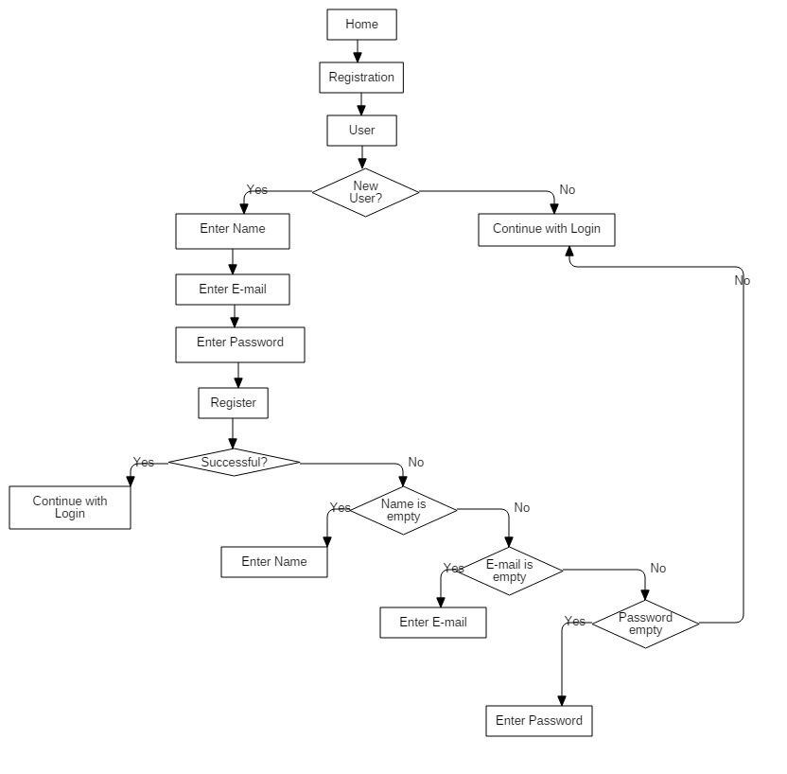
Fig..Registration

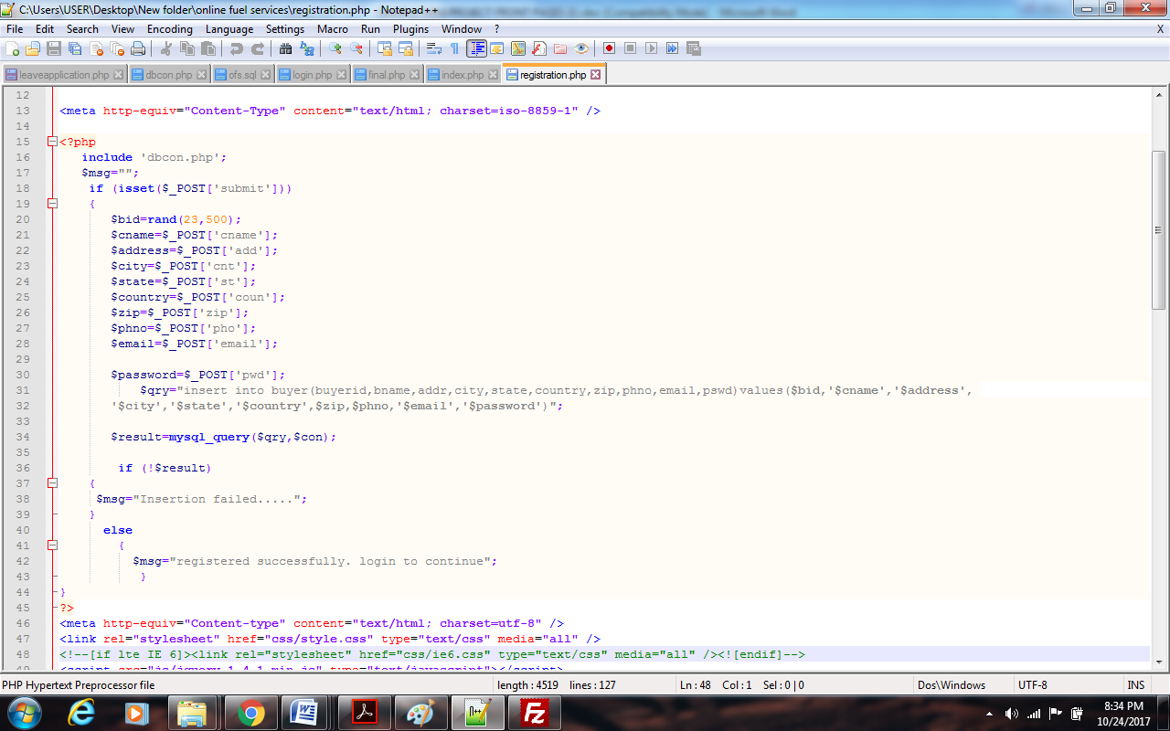
fig 3.3.3 registration code

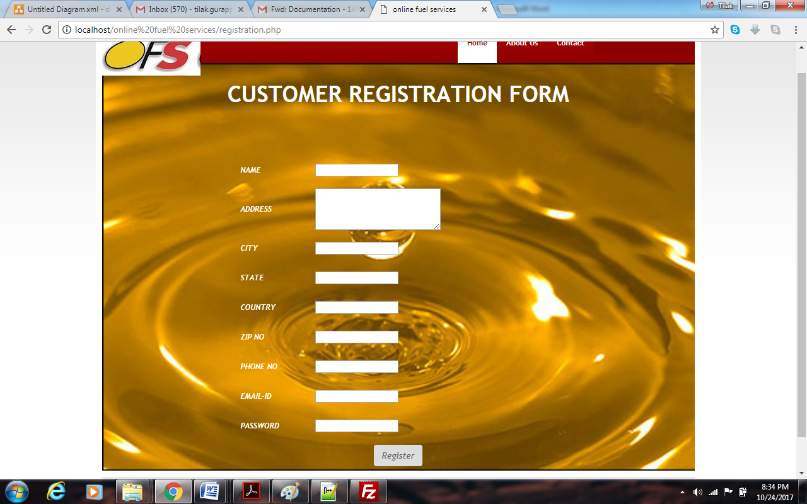
fig 3.3.4 registration webpage

login.php
Parameters : E-mail, Password
This file makes the register user to login with his/her e-mail and password.
User Manual : User enters the e-mail and password Login

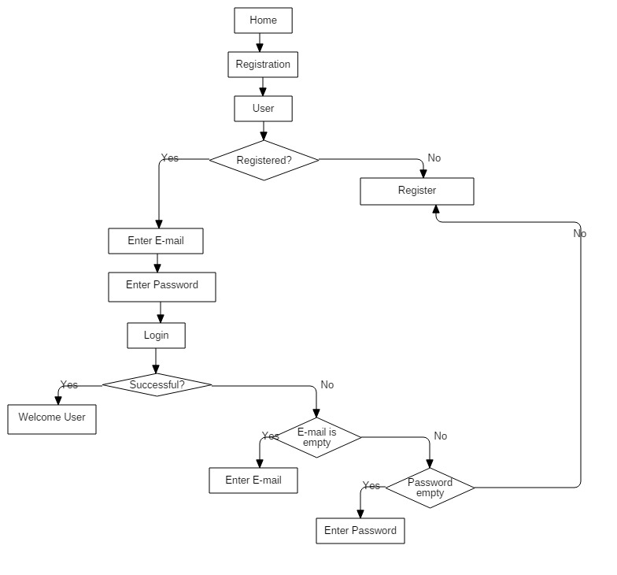
Fig.3.3.5.User Login

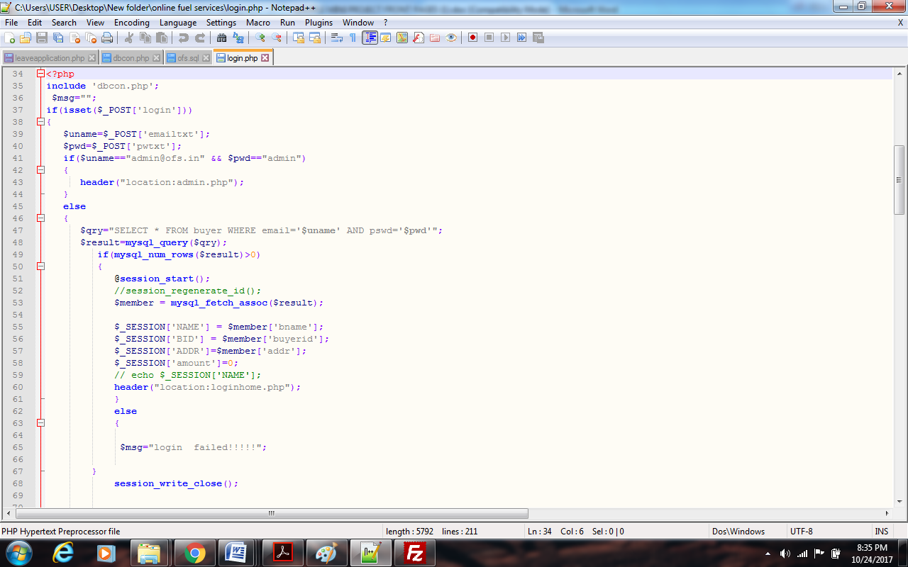
fig 3.3.6 login code
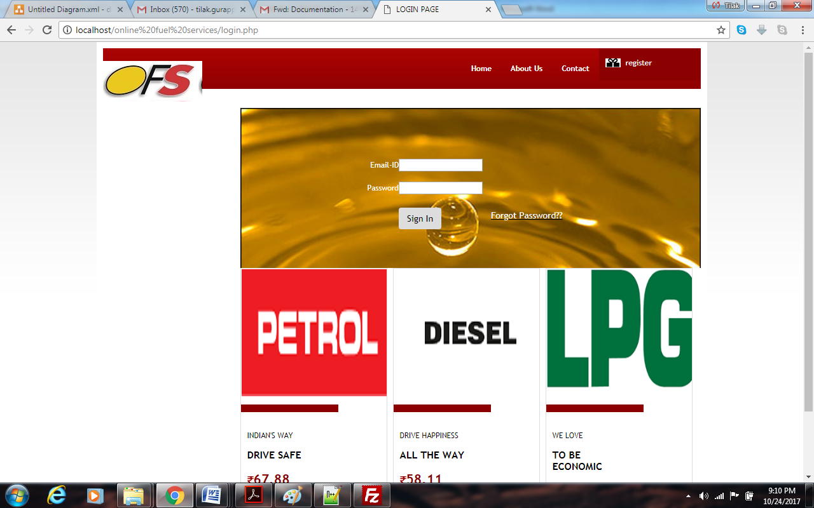
fig 3.3.7 login webpage

PRODUCTS
petrol.php ,diesel.php ,lpg.php, oils.php
Parameters : product name.
This is the header of the User which navigates to the specified paths such as seller, search, buy and logout.
User Manual :
User can select Search
User can select Buy
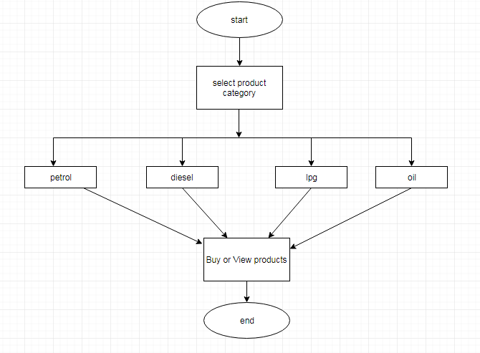
Fig.3.3.8.User primary activities
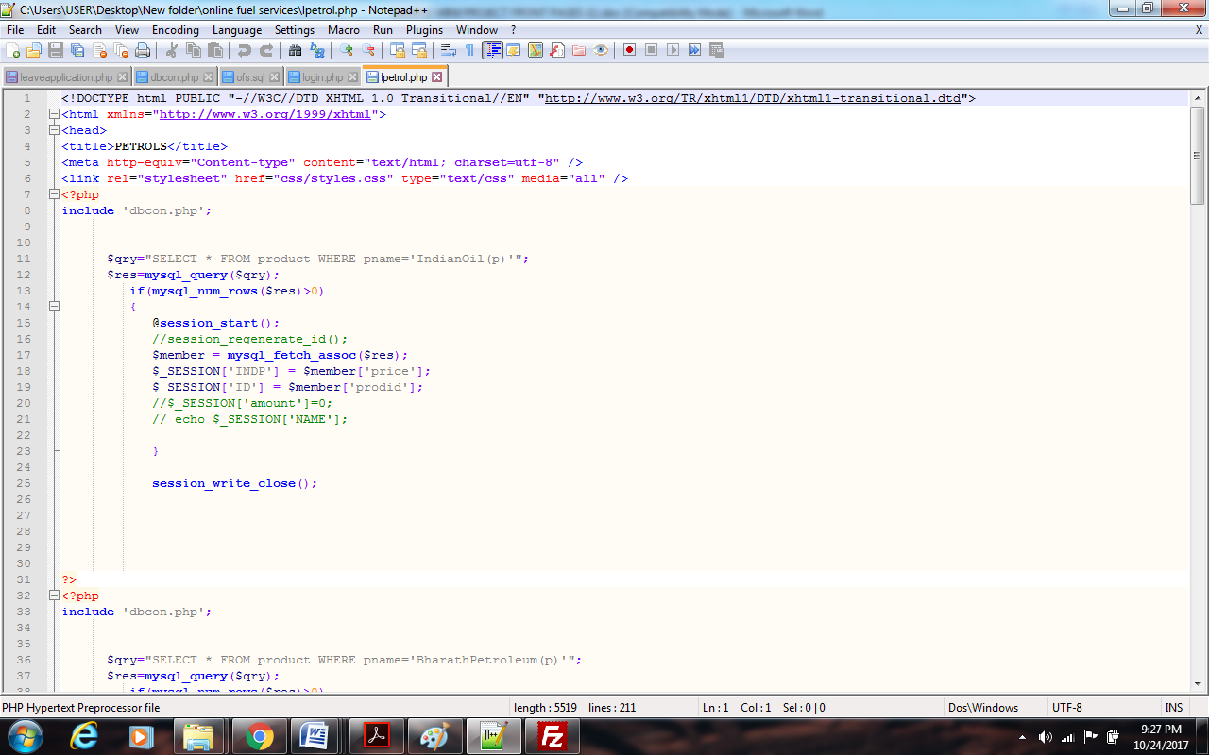
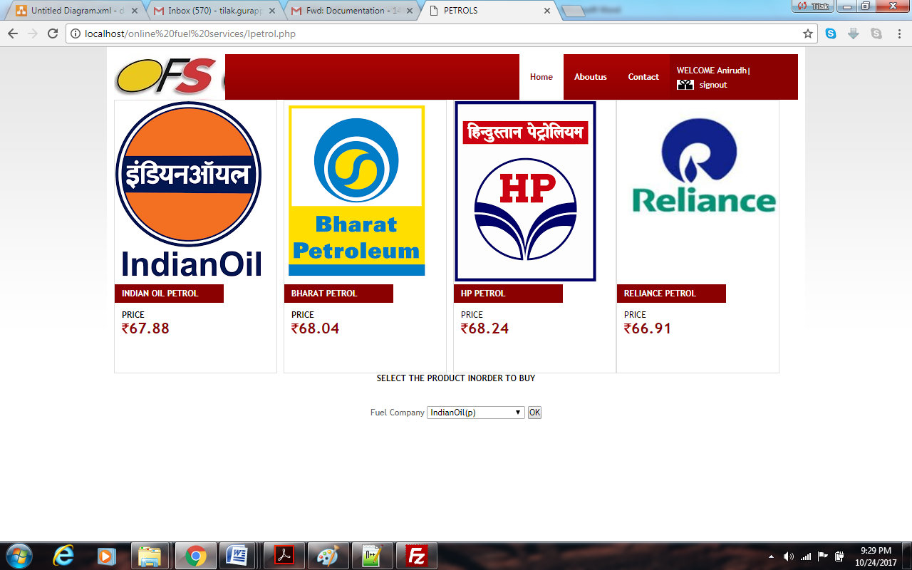
fig 3.3.9 products code and web page

cart.php
Parameters : amount,quantity,price,product,product type.
In this the products,quantity,amount selected are viewed.
User Manual : User can select Cancel
User can select Continue shopping
User can select Buy

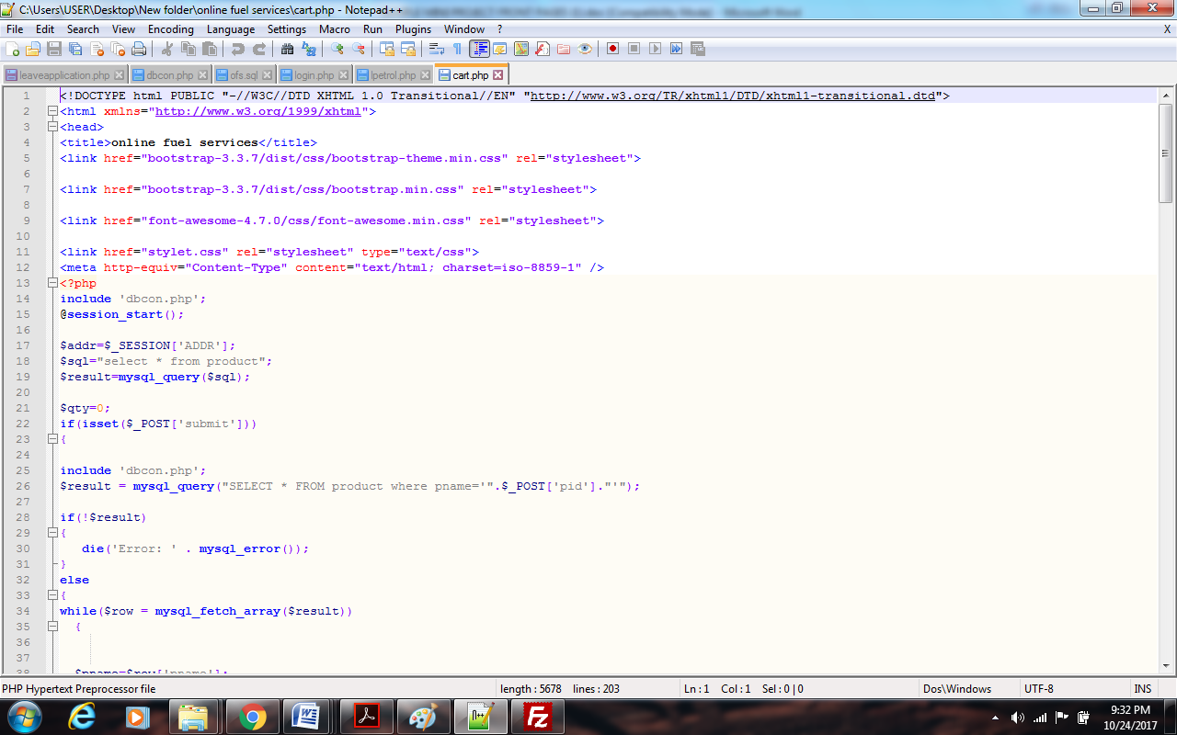

fig 3.3.10 cart page code
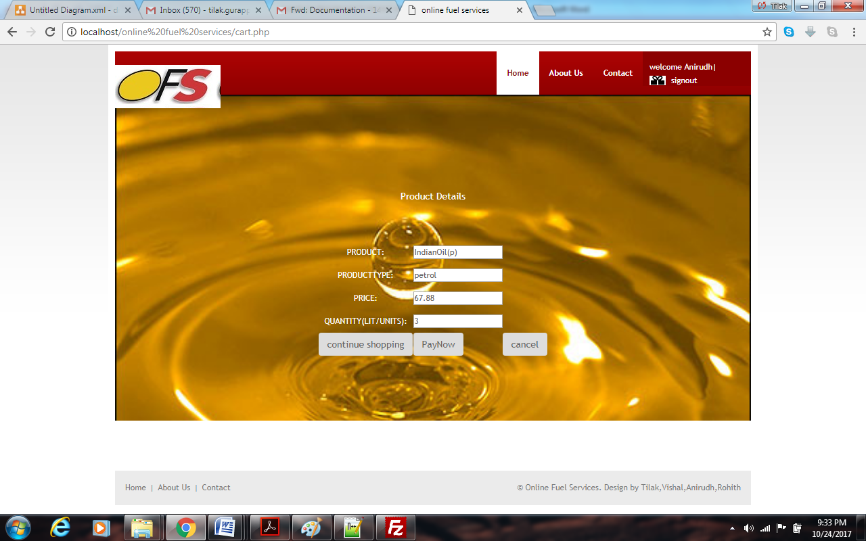
fig 3.3.11 cart webpage

checkout.php
Parameters : Payment details,card number,cvv,delivery address,amount.
This is the final page involved in the purchasing of a product. User can fill all the details to purchase or he can cancel his order.
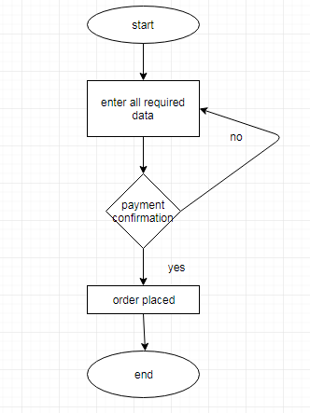
Fig.3.3.12.checkout.php

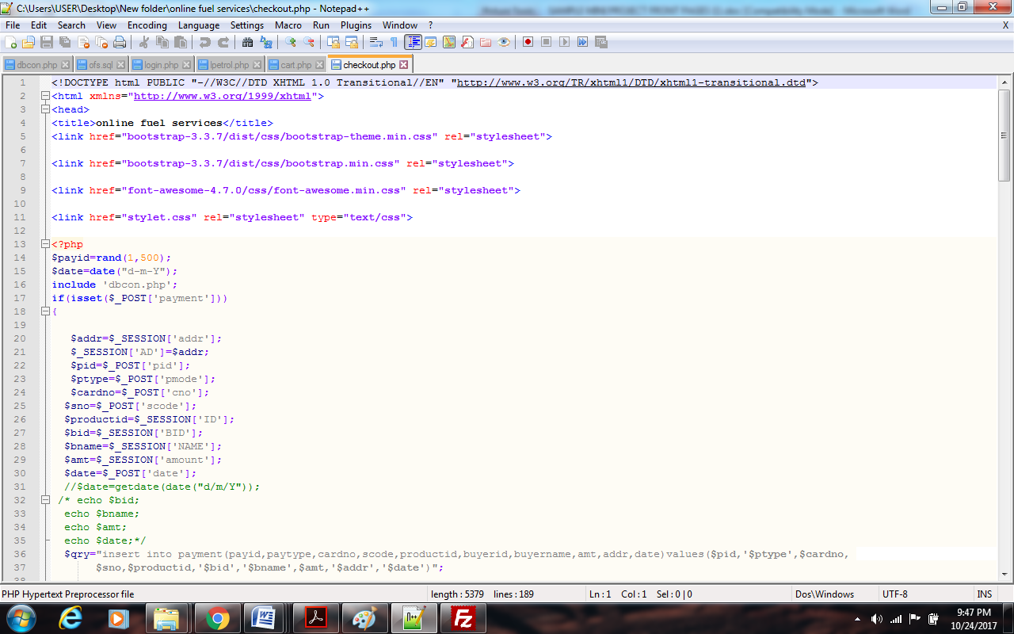
fig 3.3.13.checkout page code

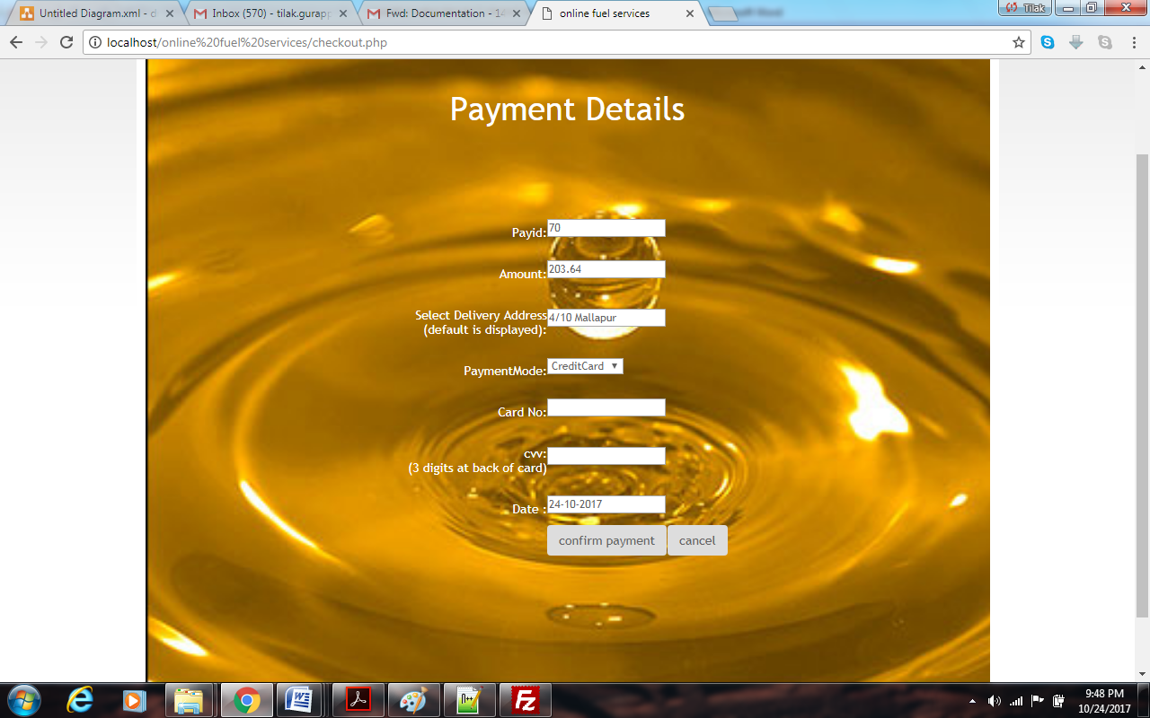
fig 3.3.14 checkout webpage

contactus.php
This is displays the information of contact
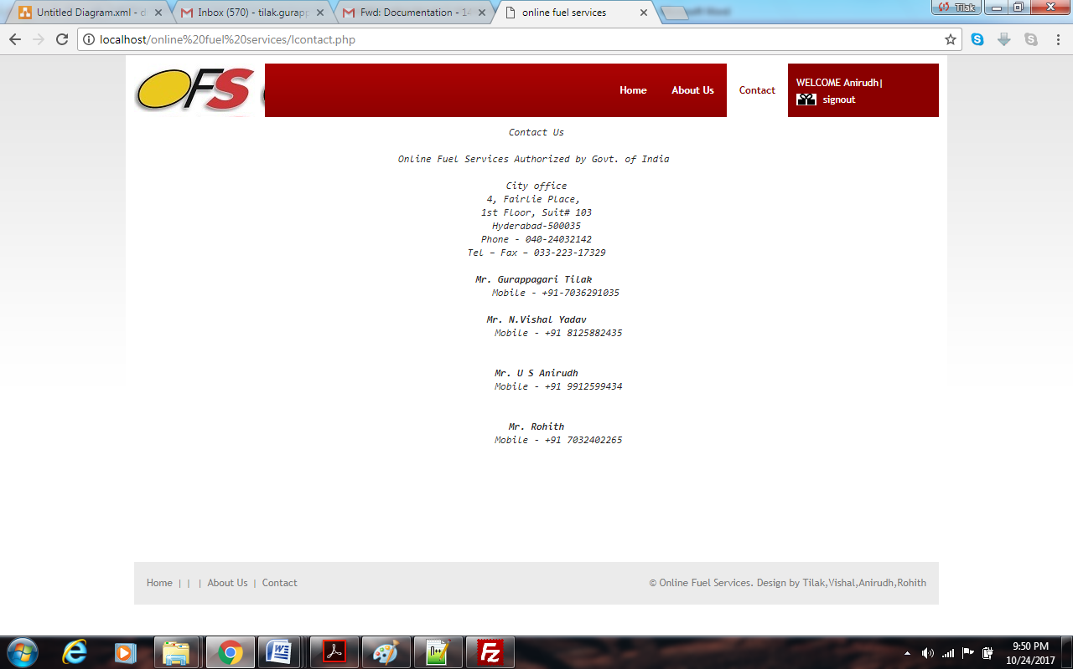
fig 3.3.15 contactus web page
aboutus.php
This gives the basic information of the website
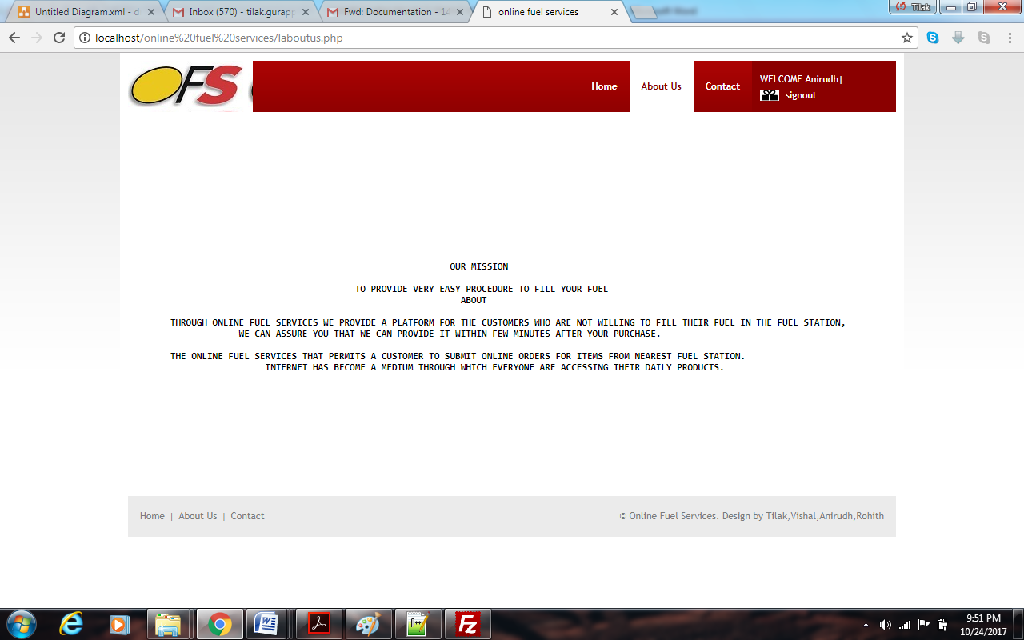
fig 3.3.16 aboutus webpage
admin.php
This is the home page of the admin .Admin can choose a product to update in this page.

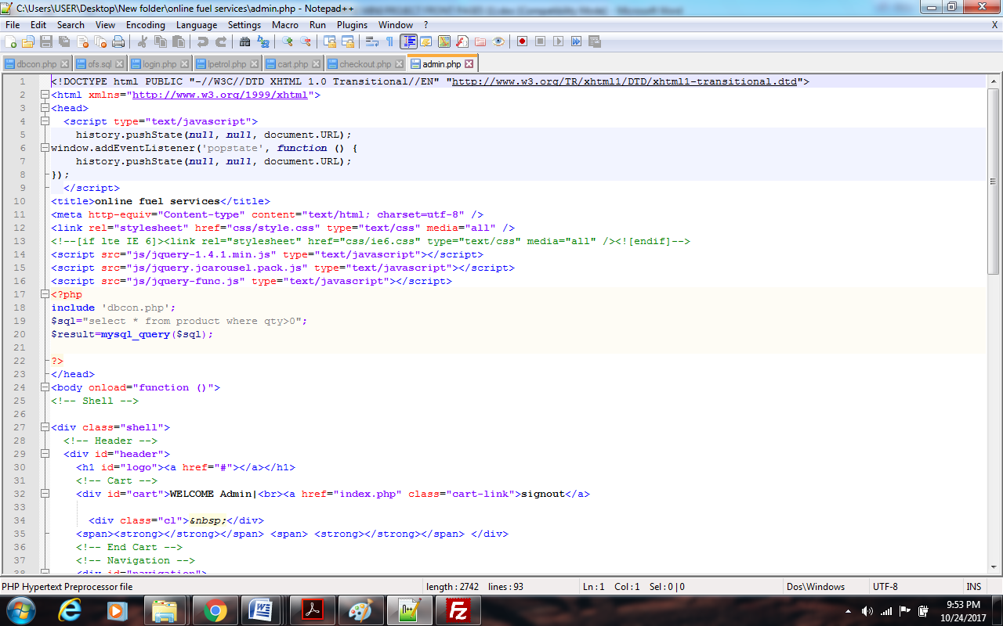
fig 3.3.17 admin page code
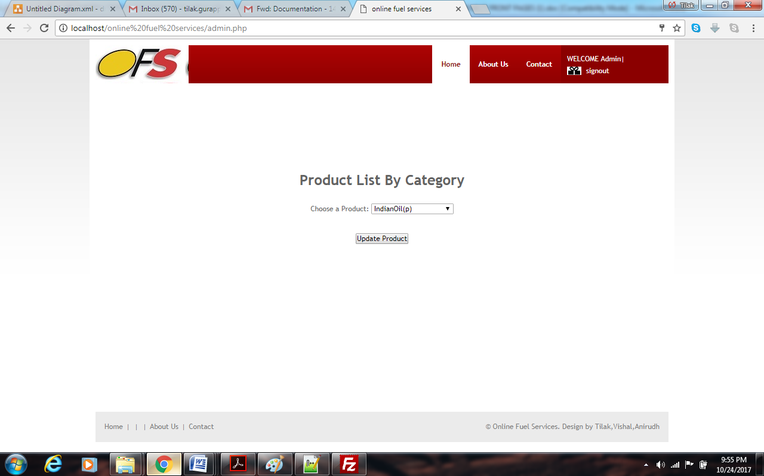
fig 3.3.18 admin webpage

upproduct.php
Parameters : product name, product type, price, quantity
This page allows the admin to update details of the products like price, quantity
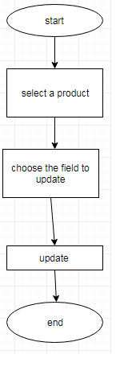
fig 3.3.19 product update flowchart
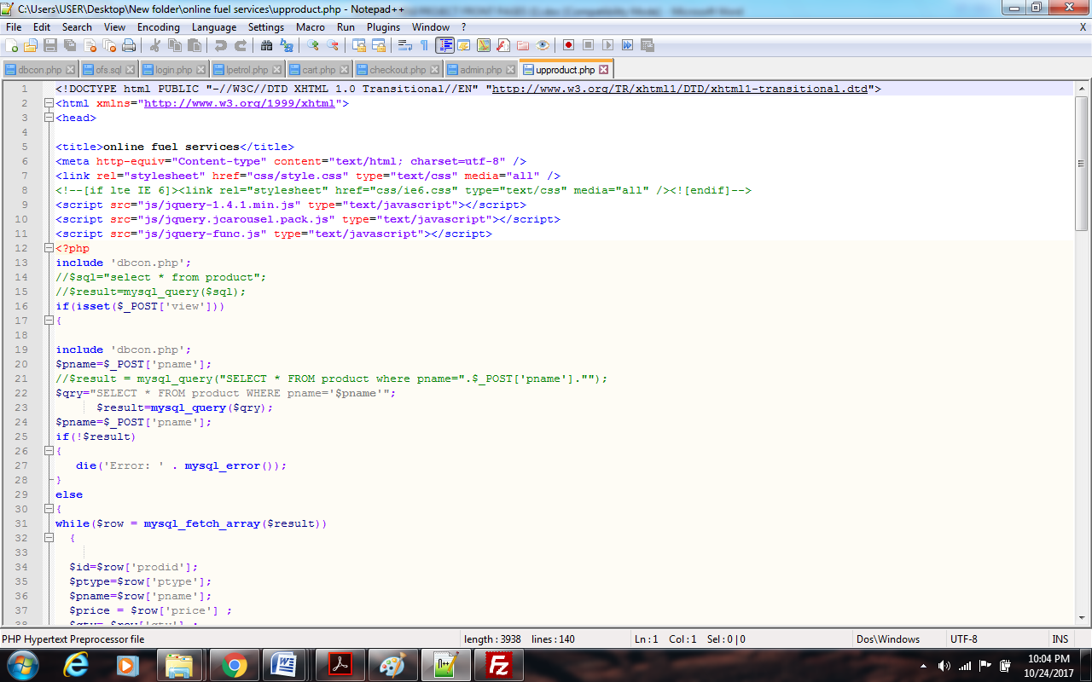
fig 3.3.20 product update code
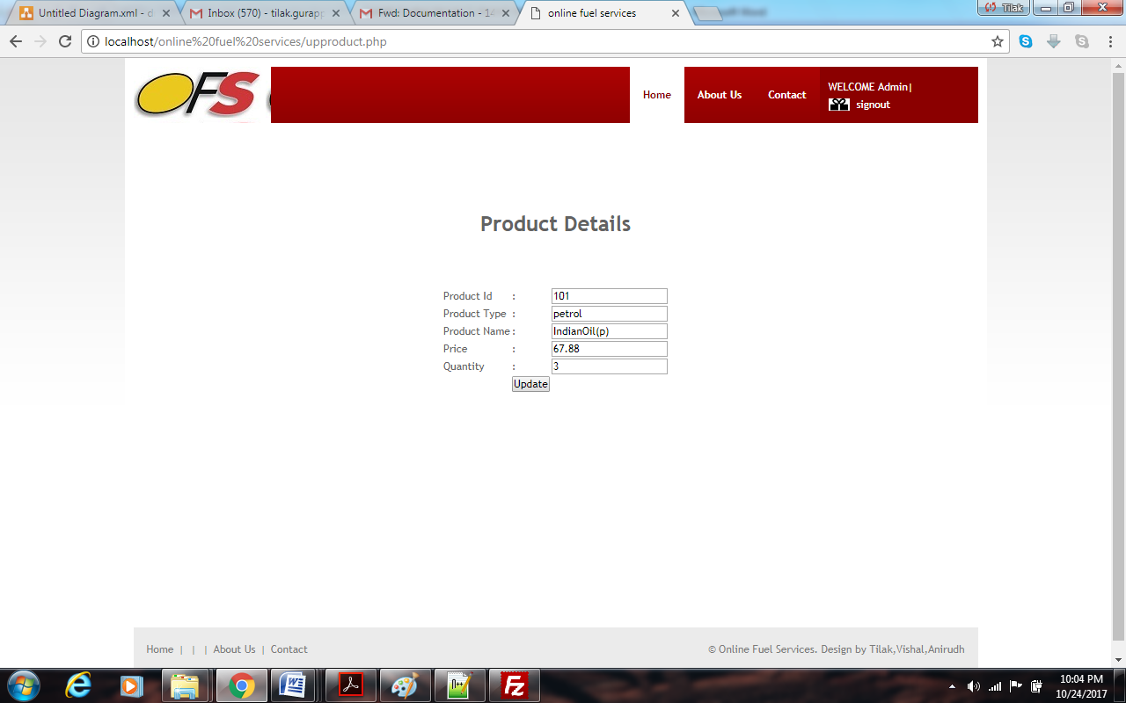
fig 3.3.21 product update webpage

userup.php
Parameters : Name, Password, address, mobile number
The user can update his details in this page
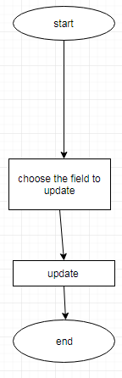
Fig.3.3.21.user information update
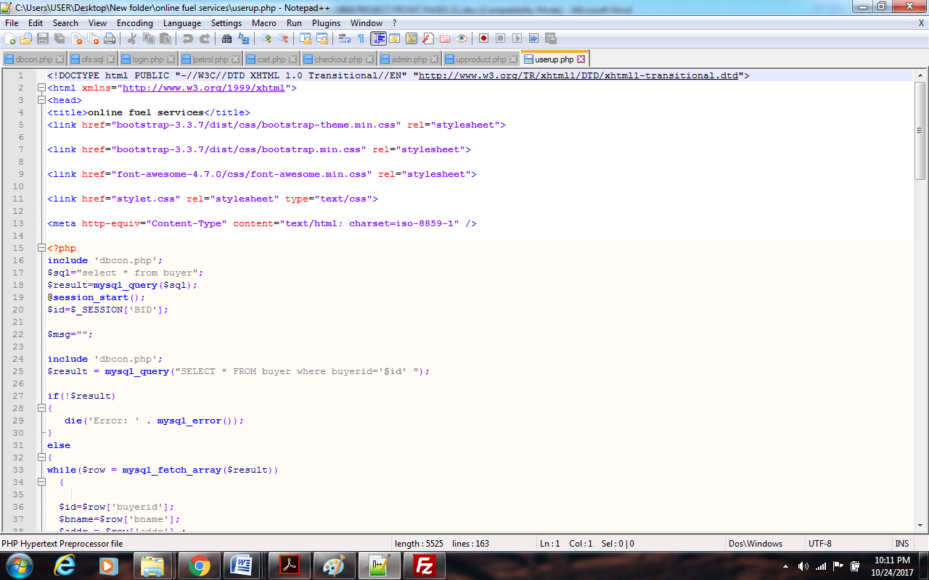
fig 3.3.21 edit info code

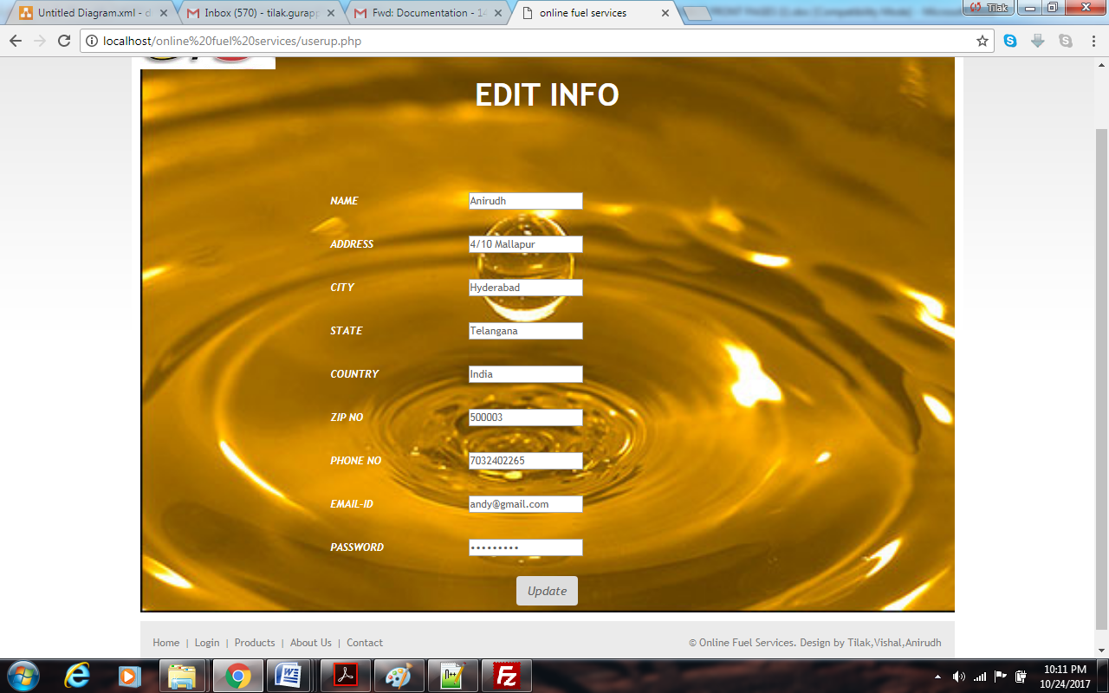
fig 3.3.22 edit info webpage

getpass.php
Parameters: mobile number
This page helps to find the forgotten password of the user. The user has to provide his phone number so that he gets his password.
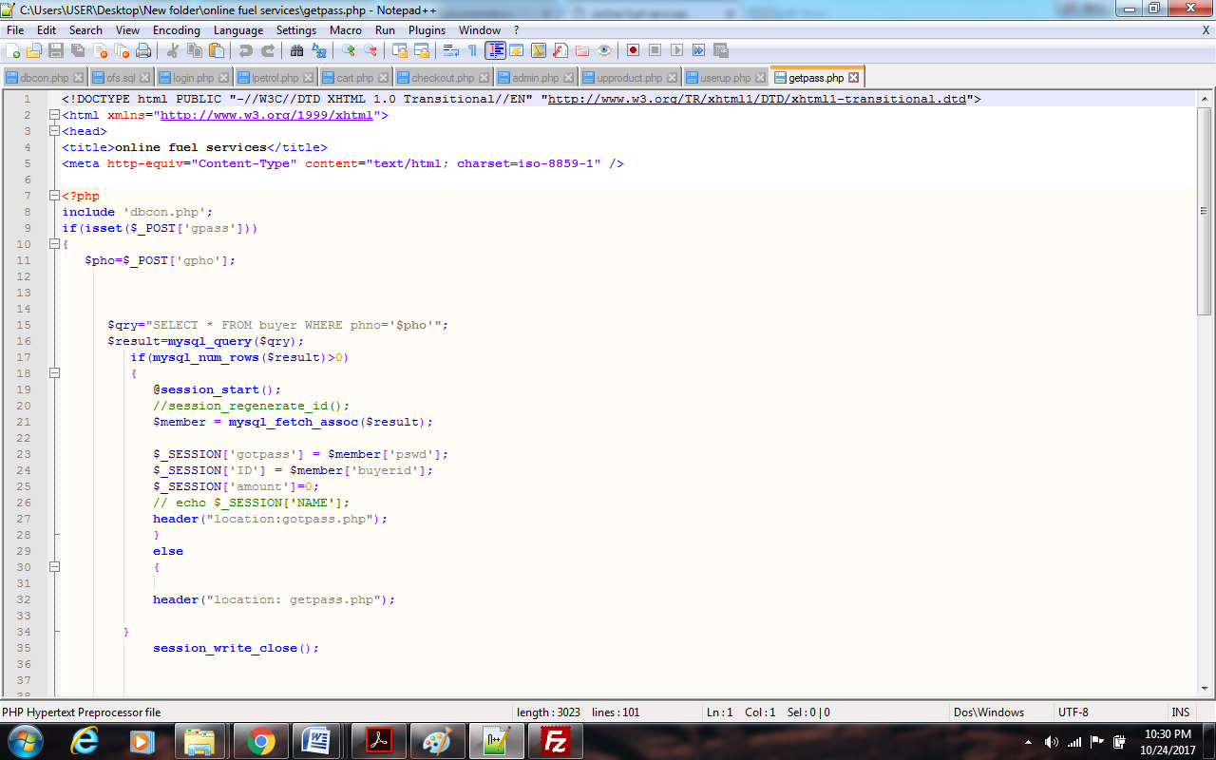
fig 3.3.23 get password code
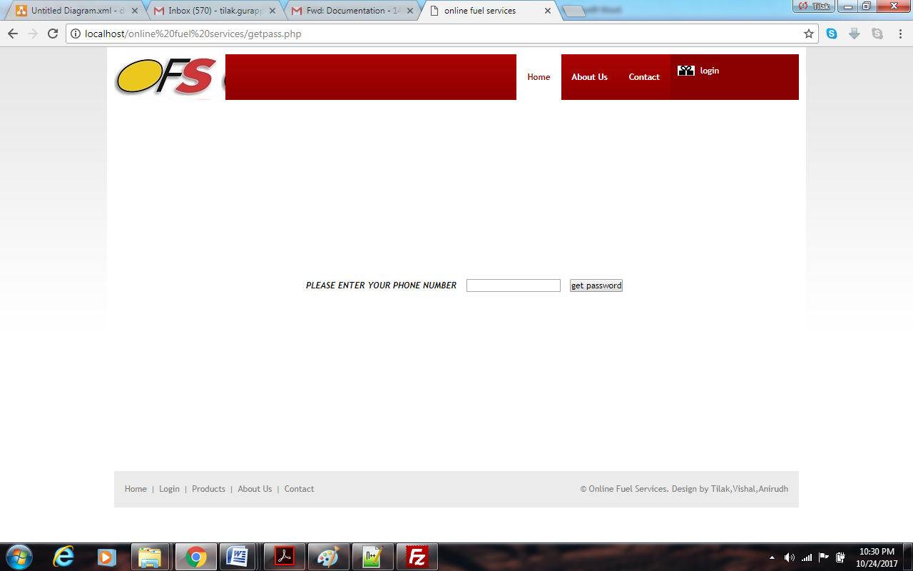
fig 3.3.24 get password web page
gotpass.php
Parameters : password
The user will be successfully retrieving his forgotten password
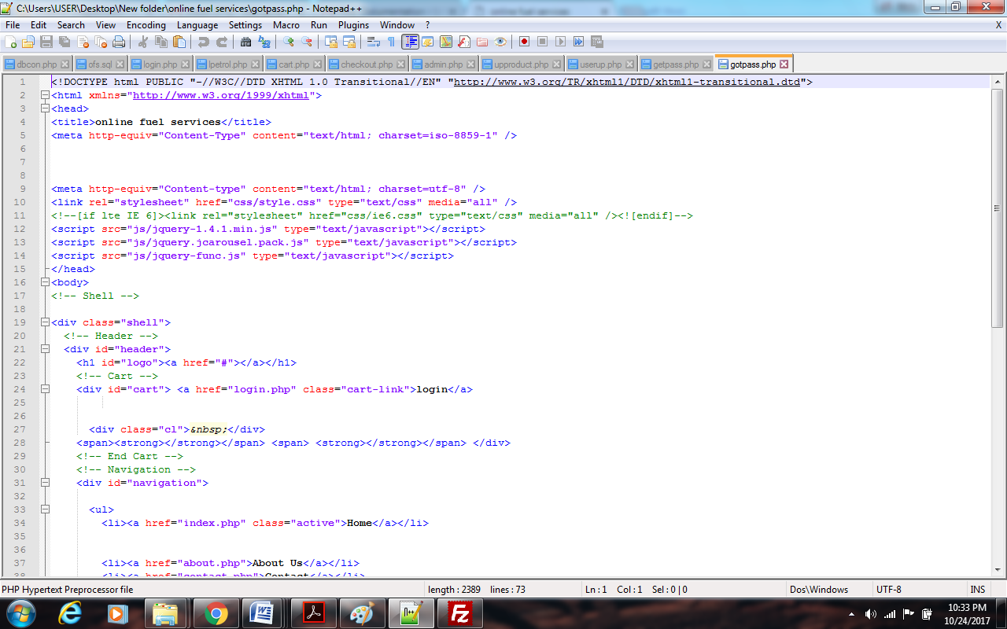
fig 3.3.25 got password code

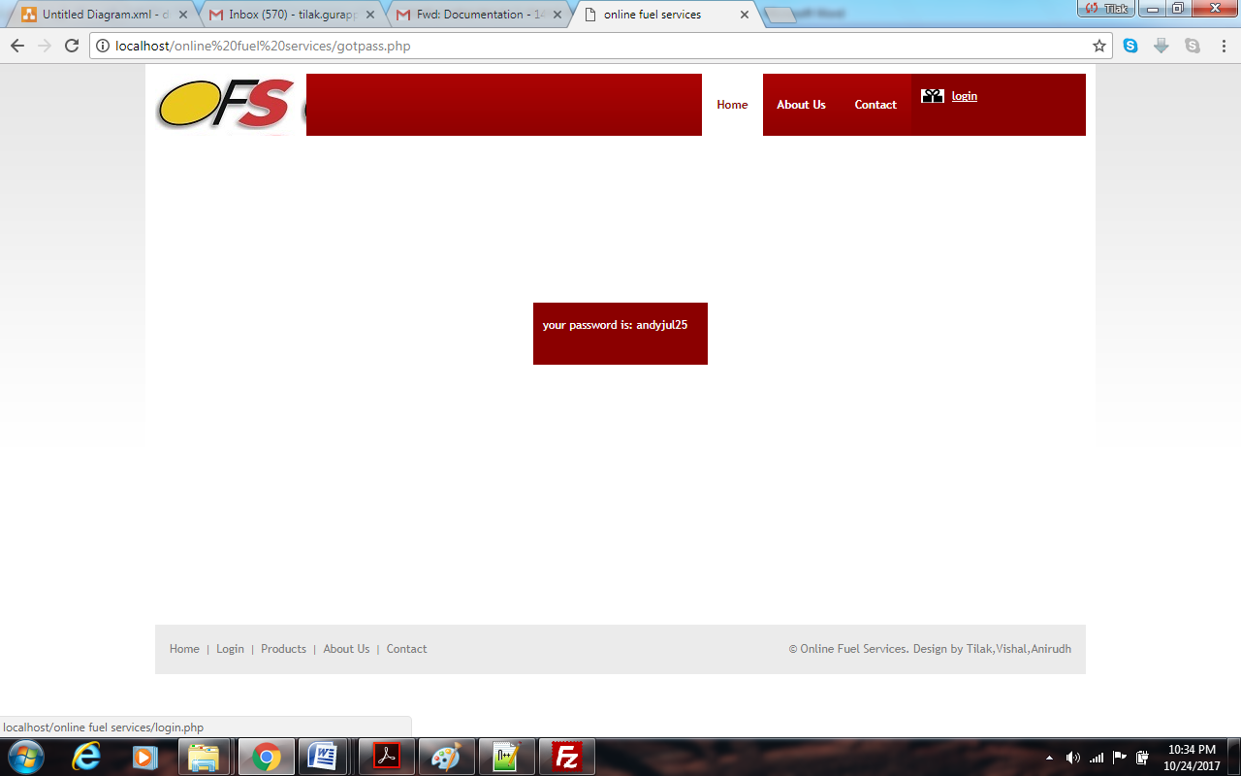
fig 3.3.26 got password webpage

dbcon.php
Parameters : none
This is the database connection for the entire project.
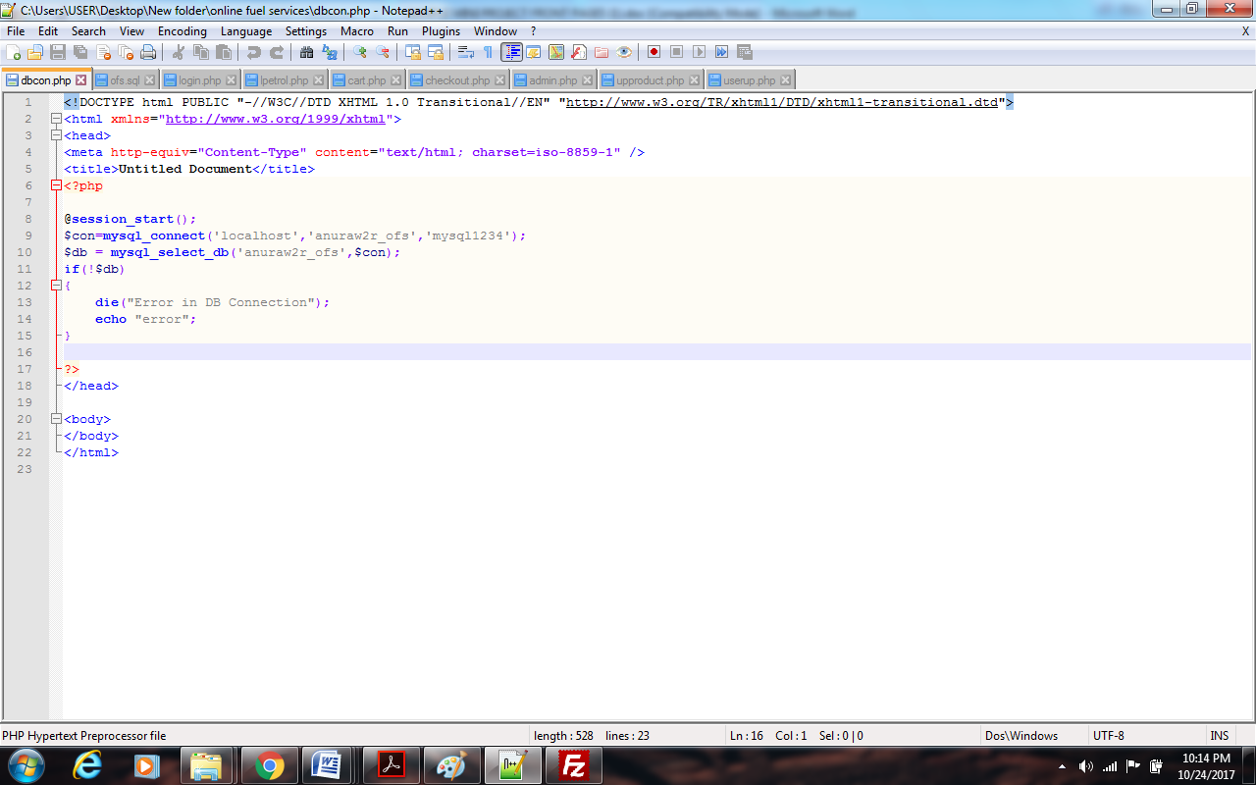
fig 3.3.27 database connectivity code

CHAPTER-4
TEST CASES
INTRODUCTION
A test case is a software testing document, which consists of event, action, input, output, expected result and actual result. Test case defined as test case is an input and an expected result. It can occasionally be a series of steps.
TESTCASES IN PROJECT
Testcase ID | Testcase Name | Function being tested | Input | Expected Output | Actual Output
1. | Registration with personal details | Details are stored in the database | Provide details | Registered successfully | Registered successfully
2. | Login | Verification is performed | Enter  E-mail and Password | Proceed to Welcome Page | Proceed to Welcome Page
3. | Admin login | Verification is performed | Enter Name and Password | Verification is performed | Verification is performed
4. | Calculating amount | Original price is retrieved from database |  | Calculated  successfully | Calculated  successfully
5. | Choosing a product | Relevant information to be retrieved | Select a product | Product details are displayed | Product details are displayed
6. | Logout | Logging out of site | Main page | Clicking logout | Logged out to home page

CHAPTER-5
DATABASE/E-R DIAGRAM
E-R DIAGRAM
An entity-relationship diagram (ERD) is a data modeling technique that graphically illustrates an information system's entities and the relationships between those entities. An ERD is a conceptual and representational model of data used to represent the entity framework infrastructure.
E-R DIAGRAM OF THE SYSTEM
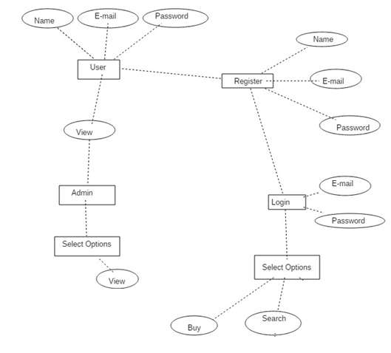
Fig.5.1.E-R Diagram

DATABASE TABLES
BUYER TABLE:
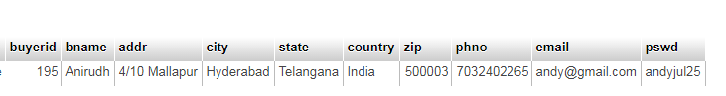
PRODUCTS TABLE:
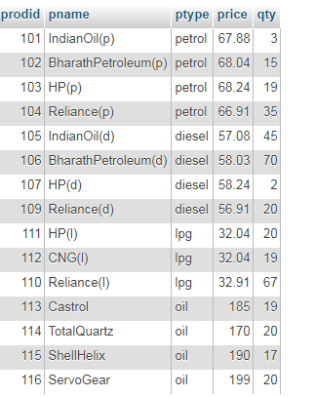
PAYMENT TABLE:
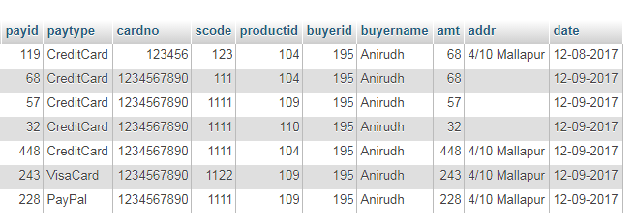

CHAPTER-6
DEPLOYMENT
DEPLOYMENT DIAGRAM
A deployment diagram in the unified modeling language models the physical deployment of artifacts on nodes. To describe a web site, for example, a deployment diagram would show what hardware components (“nodes”) exist (e.g., a web server, an application server, and a database server), what software (“artifacts”) run on each node (e.g,. web application, database ), and how the different pieces are connected.
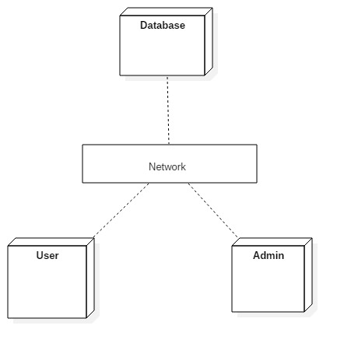
Fig.6.1.Deployment Diagram

CHAPTER-7
CONCLUSION
7.1 PROJECT CONCLUSION
ONLINE FUEL SERVICES website is completely tested and observations results success. So the application is working in according to the aim of the project. The access to the portal is given to admin who performs the tasks like selling and viewing and user who performs the tasks like buying, searching. User interface components can be made more attractive and user friendly. A proper payment method can be implemented. User location can be tracked dynamically using geolocation.

REFERENCES
- http://www.w3schools.com/
- https://www.tutorialspoint.com/php/

